Company Name: ___________________________________________________

Building Your Algae Farm

Choose everything that you would like to buy for your algae farm with a budget of $1000 (but real algae farms cost millions of dollars!). Try to maximize your algae production. You may invest in more than one option for each question.

Where will you build your farm?
- West Coast | $700
- East Coast | $400
- Northern U.S. | $500
- Southern U.S. | $600

What water source will you use?
- Freshwater $400
- Wastewater $100
- Seawater $200

What kind of reactor will you use?
- Open pond $100
- Closed reactor $300

What kind of algae will you grow?
- Diatoms $200
- Green algae $100

Total Cost (add up all the costs of the boxes you checked above) = $

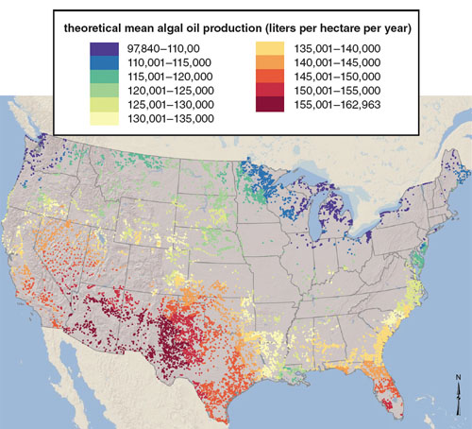
Where will you build your algae farm?
Illustration by Barbara
Aulicino. Map from the article
“National Microalgae
Biofuel Production
Potential and Resource
Demand,” by Mark Wigmosta
et al. 2011.
Water Resources Research.

Does this decide what water supply you will use?
What kind of reactor will you use?
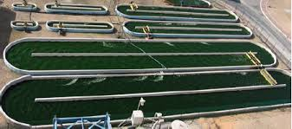

Open pond reactors
- Precipitation
- Evaporation (loss of water)
- Bacteria and predators get in
- Cheap

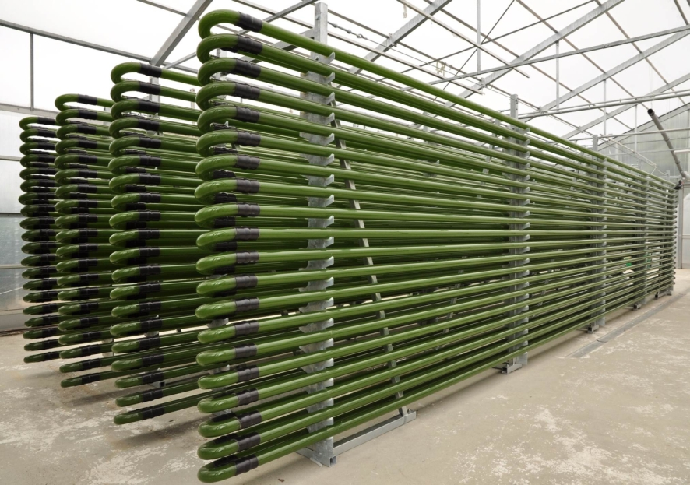

Closed reactors
- Expensive
- Easier to control
- No contamination
- Higher productivity
- Need to cool down
- Captures more light

What kind of algae will you grow?
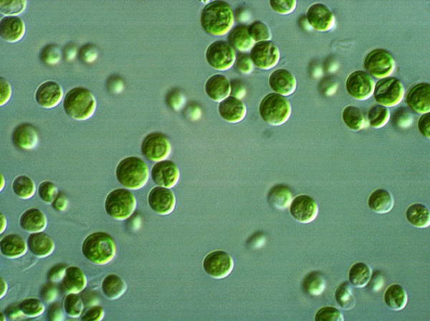
Green algae
- Higher growth rates
- Smaller cells
- Less lipids per cell

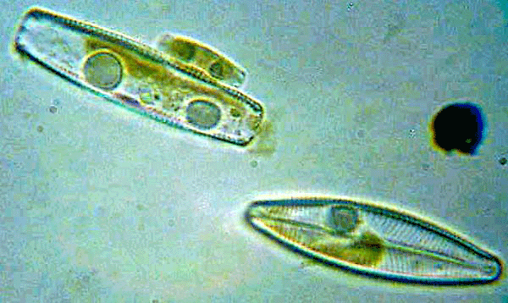
Diatoms
- Require more nutrients (silica)
- Slower growth rates
- Larger cells
- More lipids per cell

