RAPID: Linking the movement patterns and foraging behavior of humpback whales to their prey across multiple spatial scales within the LTER study region

This RAPID proposal to the Office of Polar Programs seeks to conduct whale tagging and prey mapping research from the R/V Point Sur (PS) for two weeks in February 2013 in the waters studied by the Palmer Station Long Term Ecological Research Program (LTER). The PS represents a unique and novel platform that could significantly augment the ability to integrate top predator studies into the LTER research program. Currently, whales are not systematically studied as part of the LTER, and there is limited time, space, and opportunity to conduct tagging operations and fine-scale quantitative prey mapping during the annual LTER cruise. These restrictions are not representative of the intellectual support and desire expressed by the LTER Principle Investigators to include cetacean research as a significant and permanent part of the LTER in the future. This proposal seeks to augment and improve the understanding of cetaceans within the context and framework of the LTER, and the PS represents an ideal platform for this work. In this respect, a RAPID proposal appears to be the most timely and appropriate means to take advantage of a novel platform and to conduct research that can be incorporated into the broader scientific plan of the LTER.

Intellectual Merit: Introduction
Top-level marine predators, which are long-lived and wide-ranging, integrate variability in the physical and biological environment over large spatial and temporal scales, and this is reflected in aspects of their ecology, distribution and population dynamics (Costa & Crocker 1996, Fraser and Trivelpiece 1996, Corkeron and Conner 1999). Ongoing changes in the ecology and population biology of top predator populations in the WAP region ultimately led to the development of a new unifying paradigm for understanding interactions between change in regional oceanic climatology and WAP ecosystem response. The contextual framework for this paradigm is “climate migration” and its central tenet is that the WAP is experiencing a north to south shift in ecosystem properties such that the original cold, dry polar system is being replaced by a warm, moist sub-Antarctic system (Ducklow et al. 2007).

The LTER is well equipped to study many aspects of the ecology of the WAP, including the ramifications of climate migration and ecosystem response. The primary research topics of the LTER include ‘…ecological consequences of sea-ice variability, biological processes with an emphasis on microbial and primary production as well as life-history parameters of secondary producers (krill) and apex predators (penguins, seals) and modeling that links ecosystem processes to environmental variables’. Despite this focus on apex predators, however, the ecology of cetaceans (whales) remains poorly understood. This limitation in knowledge is becoming increasingly important as whales are occurring in unprecedented densities in this area, likely exerting significant predation pressure krill populations (Nowacek et al 2011).

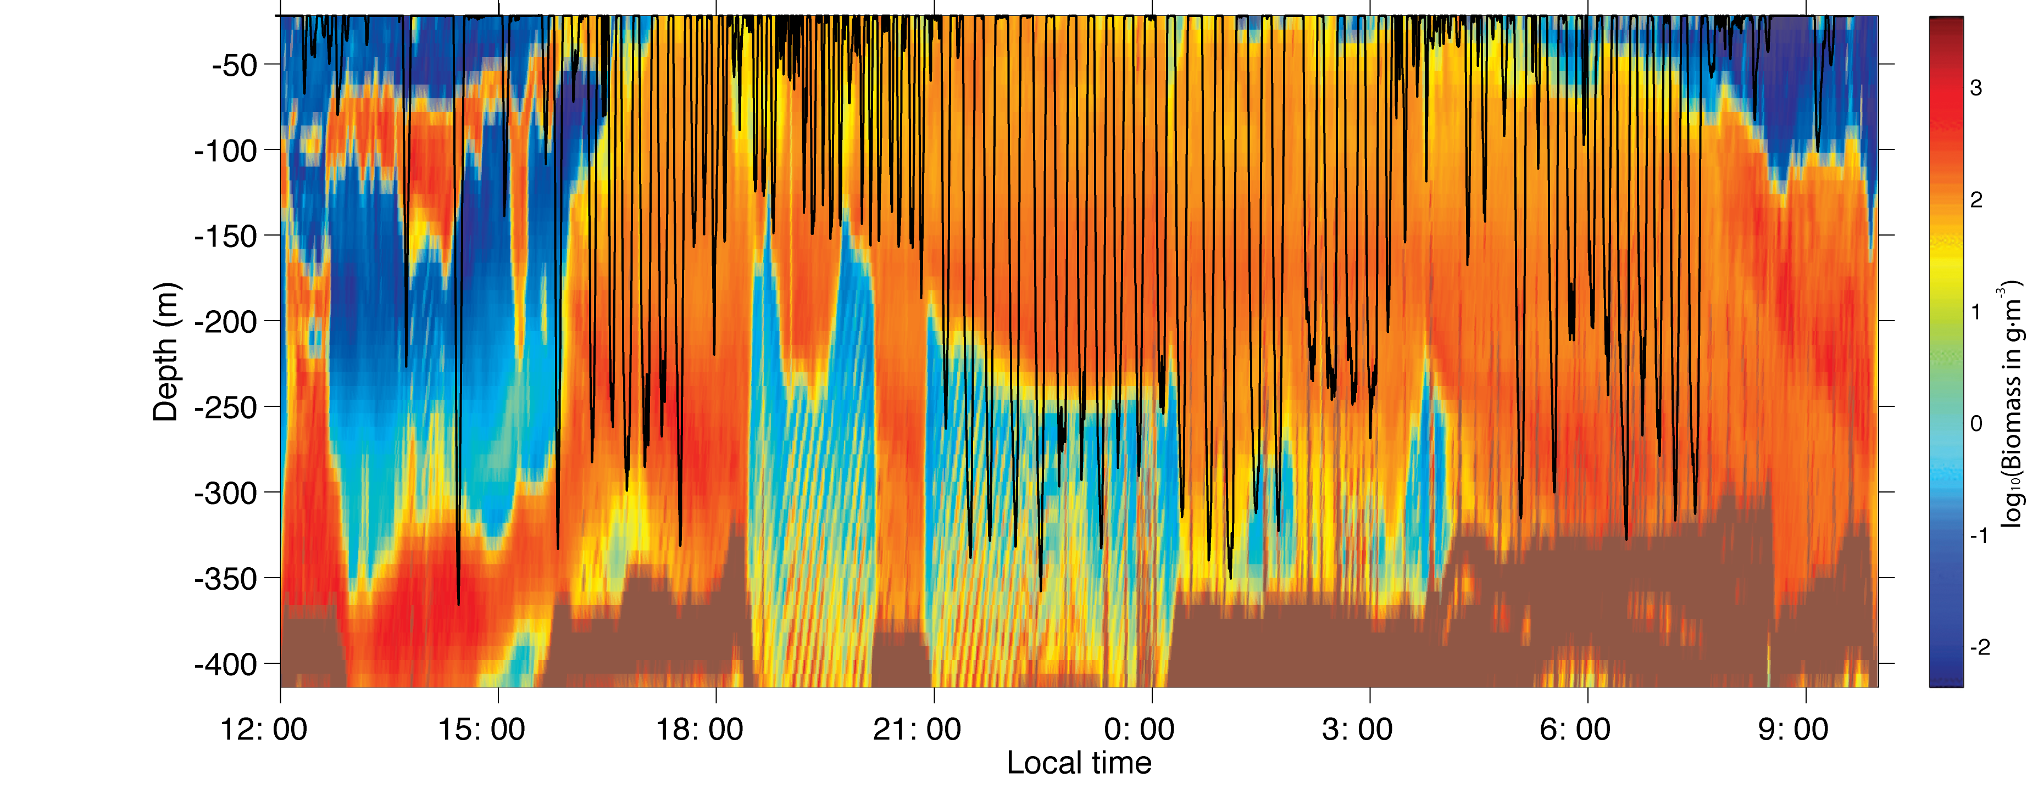Throughout the Southern Ocean, the diet of humpback whales is comprised almost exclusively of Antarctic krill. Recent work by Friedlaender et al. (2006, 2008, 2010) described the distribution of humpback whales as being primarily dictated by krill distribution and abundance. Based on recent information derived from archival tags, humpback whales dive as deep as 400 meters to feed in nearshore waters around the WAP and alter their foraging depth in response to diurnal changes in the vertical distribution of krill (Figure 2, Nowacek et al 2011). However, relatively little information exists on the distribution, movement patterns, and foraging behaviors of humpback whales during summer months in the LTER study region. Since the cessation of commercial whaling operations in the Antarctic in the last half of the 20th century, humpback whale populations have increased in all of their known breeding ranges. Thus, although they are a key predator in the Antarctic marine ecosystem, humpbacks have not yet been integrated into ecological models in the Antarctic. This information gap is largely a historical artifact resulting from a lack of previous dedicated research effort.
Figure 1. Dive profile of a humpback whale overlaid on krill density. Daytime resting behavior is indicated by the lack of dives. The whale’s diving behavior was measured by the tag we will use and tracked the vertical movement of krill at night. Krill density was measured within 100 s of meters from the tagged whale. From Nowacek et al. 2011.

Hypotheses & Research Goals
Using a combination of long-term satellite-linked tags and short-term suction cups tags concurrent to quantitative surveys of prey throughout the water column, the following hypotheses are presented:

Broad Scale: during summer months, the broad-scale movement patterns of humpback whales will be tightly coupled to the distribution and abundance of Antarctic krill at similar scales and the oceanographic features that enhance local prey availability.

H: Whale foraging areas defined from kernel density analysis will be located in regions of high krill density and oceanographic features that enhance krill availability
H₀: the broad-scale movement patterns of humpback whales in summer months is not linked to the distribution of their prey and is random with respect to prey distribution

Fine-Scale: at fine-spatial and temporal scales (~24 hours), humpback whales will maximize their energy input by feeding in a manner consistent with optimal foraging theory.

H₁: Whale foraging depth will reflect the vertical density of prey. A minimum prey density threshold exists below which it is not efficient for whales to continue feeding.
H₁₋₀: no relationship exists between the density of prey targeted by foraging humpback whales and the depth at which whales forage

H2: Whale foraging likelihood will be greatest in areas of high patch density (# of patches / km) and high krill density (# of krill / patch) and whales will not forage in regions with low prey density.
H₂₋₀: no relationship exists between the density of prey targeted by foraging humpback whales and likelihood of whale foraging.

With dedicated fine scale prey-mapping, the scales of krill patchiness within the LTER study region can be identified. This is critical to understanding how predator-available krill hotspots form and dissipate. This is a main concern for future LTER hypotheses regarding how climate change will affect krill distribution and krill availability to predators that are either tied to land (e.g. penguins) or range broadly (e.g. whales).

Methods
This proposal seeks to use the PS for two weeks of dedicated time in the second half of February 2013 to deploy tags on whales and conduct oceanographic and prey mapping surveys The field team (8-10) and equipment would fly directly to King George Island from Punta Arenas, Chile, and deploy to the PS directly. Work would then occur around Anvers Island and the LTER study grid where tagging and prey mapping work would occur. The team would then return to King George Island to fly back to Punta Arenas after two weeks.

In 2009-2010, the PIs successfully conducted ecological research on humpback whales and their prey in this region using similar methods, proving both conceptually and scientifically that such research was tractable in Antarctica from a larger vessel (see Ware et al. 2010, Nowacek et al. 2011, Tyson et al. 2012, Johnston et al. 2012). In 2011, 6 satellite tags were successfully deployed on humpback whales during the LTER research cruise by the PI. Satellite tag duration averaged >60 days and are providing significant insights into the distribution and movement patterns of whales within the LTER study region (Figure 2). A focused effort in 2013 would allow a sample size large enough for robust animal movement analysis to rigorously test hypotheses about the spatio-temporal relationship amongst whales and their prey in summer.
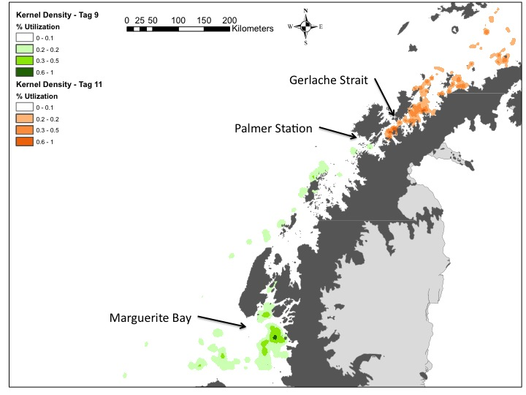
The PS is ideally suited for fine-scale prey mapping work and support of tagging operations in the ice-free waters around Palmer Station. Satellite tags will be made available in-kind through an international collaboration with the Australian Antarctic Division, and all other field equipment necessary for our proposed research is currently maintained by the PIs. In fact, the research proposed here has been highlighted and supported by the Southern Ocean Research Partnership and International Whaling Commission. Thus, project costs will be modest. If provided the opportunity test the operational and ecological hypotheses, the ability to integrate whales into the scientific structure and paradigm of the LTER will be greatly enhanced.
Figure 2 Area-density use map for two satellite-tagged humpback whales around the WAP. Each whale (green and orange) spent significant time in nearshore waters feeding. Tag durations were both > 80 days.
Whale tagging
Two types of tags will be deployed on humpback whales during the study: one to record fine-scale, high-resolution movements and dive behavior over 24-48 hour periods and another for broad-scale movements over weeks to months (Figure 3).

At fine-scales, DTags (Johnson and Tyack 2003) and a customized visualization software package to analyze fine-scale movement patterns, behavior and dive data (e.g. Figure 4, Ware et al. 2006, Ware et al. 2010) will be used. DTags are small (200cm³), lightweight (190g), non-invasive archival tags that attach via small suction cups. The tags can be programmed to remain on a whale and collect data for up to 2 days. The DTag uses 3-axis accelerometers and magnetometers, and a pressure sensor to measure pitch, roll, heading, and depth, respectively, at 50 Hz. The tag also simultaneously records sound up to 96 kHz. Whale locations are georeferenced from a Fastloc GPS system (Sirtrack F2G 134A marine data logger) on the tag that can acquire locations rapidly (100ms) when the animal surfaces and can be accurate to 55m (95%) (www.wildtracker.com/fastloc). All data are stored on the tag and downloaded through a USB data port for calibration and analysis. The tag also contains a VHF transmitter used to follow the tagged whale at the surface and to aid in tag retrieval. A programmable release mechanism allows the tag to release when desired.
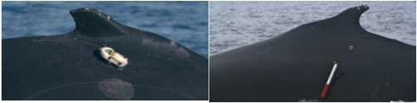
Figure 3 A satellite-linked tag deployed directly below the dorsal fin and in the blubber of a humpback whale (right). A suction-cup attached DTag deployed on a humpback whale (left). Both of these tags will be to understand the long-term movement patterns and fine-scale feeding behaviors of humpback whales.

DTags are deployed via a hand-held carbon-fiber pole (8m) from a small inflatable boat. The PIs have successfully employed DTags since 1997 on 13 species, including humpback whales in Antarctica (e.g., Nowacek et al. 2001, Ware et al. 2010, Nowacek et al. 2011). In 2009-10, the PIs successfully deployed over 20 DTags on humpback whales in Antarctica, deploying at least one tag on every operational day and tag recovery rate was 100%. We will deploy at least 5 Dtags tags during the cruise.

At broader scales, the long-term movement and behavioral patterns of humpback whales will be studied using trans-dermal Argos-linked satellite tags. These tags consist of a custom-designed, implantable housing that contains a Wildlife Computers (Redmond, WA) Spot 5 transmitter. Tags are deployed with a compressed air gun using a projectile housing to aid in accuracy (Gales et al. 2009). The tags are deployed from small inflatable boats. The tag is designed to penetrate beneath the skin and hypodermis and anchor in the underlying blubber; it is built from surgical grade stainless steel and is sterilized before deployment. The tag is powered by a single AA battery that provides up to 270 days of active life while providing at least one location per day. PIs have been instrumental in developing, designing and deploying these tags successfully on humpback whales (Gales et al. 2009). In 2012, these tags were successfully deployed on 6 humpback whales around the WAP, with an average transmission life of > 60 days (Friedlaender unpublished data), similar to other deployments in the Southern Ocean (Gales et al. 2009). Daily positional fixes for all satellite-tagged whales will be emailed to the ship and allow the research team to maneuver the ship to those locations for prey mapping.
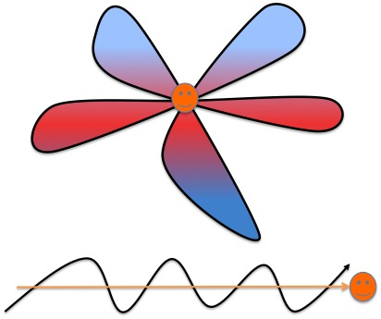
Prey Mapping
Concurrent to tagging operations, two sets of echosounders will be used to map the distribution, abundance, and behavior of krill. Fine (< 1km) and broad scale (~10km) prey mapping will allow examination of patch structure available to individual predators but also understanding spatial patterns in the distribution and abundance of Antarctic Krill. Dual frequency Simrad EK60 and ES60 echosounders will be used (38 & 120 kHz, and 38 & 200 kHz) to measure krill distribution and biomass. Both acoustic systems will be calibrated at the beginning of the cruise using a sphere of known target strength (e.g. 38.1 mm, Foote et al. 1990) and net tows will be used to measure length-frequency distributions for biomass conversion according to CCAMLR protocols (Jarvis et al. 2010).
Figure 4 Prey mapping strategies around tagged whales. Clover-leaf sampling strategy around feeding whales (top), following sampling behind a traveling whale (bottom). Both strategies will be employed at both the fine (~1km) and meso (~10km) scale by a zodiac and the PS respectively.

When DTags are deployed, a zodiac with transom-mounted echosounders (38 and 200 kHz) will map prey at fine scales using a clover design (Figure 4) while the PS will map prey at the broad scale at 38 and 120 kHz. The PS will be the primary survey vessel for satellite tagged animals and the fine scale prey mapping will be used to map close to shore where the larger vessel is unable to survey. This combination will allow the spatial scale of prey schools to be estimated for use in understanding the foraging ecology of Antarctic humpback whales.

Ecosystem Observations
In order to relate the broad-scale movement patterns of satellite-tagged whales to oceanographic and environmental conditions, underway sampling, remote sensing, and archived information from past and current LTER cruises will be used. CTD casts will be made to determine water column properties, while underway sampling and remote sensing imagery will help define primary productivity. Large-scale water mass structure, bathymetry, and primary production will be defined from data collected during LTER cruises. At the fine-scale, during suction-cup tagging operations, underway sampling from the PS, CTD casts, and ADCP measurements will help define the oceanographic environment in the vicinity of both tagged whales and krill.

Analytical Framework
A spatially and temporally explicit analytical framework will be employed to help test the core hypotheses presented above. The fundamental question of how krill dynamics influence humpback whale distribution and behavior in the WAP is central, and both horizontal and vertical scales of variability will be used to inform analyses of krill predator behavior.

To test the hypotheses, the following will be used:
Analysis focus 1: Derive consistent animal movement and dive behavior from telemetry data
Telemetry data, gathered from a variety of sensors exhibiting different levels of precision, sampling intervals and expected error structures, will be used in this analysis. The approach must also account for unobserved patterns in the environment, species movement and predator interaction. Because of these error structures and potentially unobserved processes, it becomes necessary to separate the observed data from the unobserved process in an explicit manner. A State-Space Model (SSM) framework allows for the estimation of expected paths from observed data by employing joint process and observation models (Jonsen et al. 2003, Jonsen et al. 2005). This will allow processing of telemetry data into estimated paths from multiple sensors while also providing spatially explicit estimates of error. SSM analysis will provide a model of a likely track with estimates of error without the use of speed, distance or angle filters. The SSM modeling approach provides for three important parameters to be explicitly estimated in the process: behavioral mode, spatial autocorrelation and a temporal regularization of the sampling interval of the whale movement tracks.
In addition to deriving more robust and comparable tracks from telemetry data, feeding behaviors can be deduced from observed dive characteristics. The data recorded by the short-term tags can be used to determine explicitly when and where the whales are actually foraging (e.g. Ware et al. 2010). The animal’s location and behavior can then be used as response variables in ecological models to better understand humpback whale ecology in the WAP.
Analysis focus 2: Develop krill and whale resource Utilization Distribution (UD) kernel areas in x,y,z dimensions
The second step in the analysis is to model the distribution of krill, fine-scale foraging areas, and broad-scale resource use areas from animal movement and dive behavior. For each component, the Utilization Distribution (UD) kernel areas method (van Winkle 1975, Rader & Krockenberger 2006, Keating & Cherry 2009) will be used. This approach considers three dimensions (x,y, and z), and in this case including animal dive movement in the z-dimension. Terrestrial applications of this approach have modeled the spatial components of animal distributions based on topographic (elevation and aspect) effects (Keating & Cherry 2009).
Fine and broad-scale spatial movements will be modeled based on oceanographic features (depth, distance and prevailing current/tides) and krill parameters (school size, shape, density, and distribution). Similar to Figure 2, density grids will be generated for tagged whales and compared with the suite of environmental variables collected underway and from remotely-sensed sources.
Analysis focus 3: Identify any explanatory mechanisms, ecological lags, and behavioral responses that further explain observed patterns
The final step in the analysis will be to integrate and interpret the outcomes of the previous steps to identify potential explanatory mechanisms, ecological processes, or behavioral responses that explain observed patterns across multiple scales in space and time. It is anticipated that the steps outlined above will allow for direct tests of the stated hypotheses, but that a more synthetic final analysis phase will assess how each component fits together. To better assess the interactions between the oceanographic environment, prey distribution, and whales an ensemble modeling approach including Generalized Linear and Additive Mixed Models (GLMMs and GAMMs), Maximum Entropy (MAXENT), non-parametric classification approaches (e.g. random forests), and a path analysis and structural equation (SEM) approach (Mitchell 1992, McCune et al. 2002, Arhonditsis et al. 2006, Vile et al. 2006, Lee 2007, Grace et al. 2010) will be used. A suite of models can identify relationships that are significant independent of statistical techniques, and can average across model biases (Segurado et al. 2006). This method will provide a full framework to layout out and test the assumptions and hypotheses regarding how the behavior of humpback whales is affected by the behavior of their prey.
Broader Impacts
The successful completion of the proposed research would have far-reaching implications for the use of a smaller vessel to augment scientific capabilities around Palmer Station. The proposed research would also help to increase the scientific scope of the LTER. By successfully adding cetacean research, the LTER can provide a more holistic understanding of the effects of climate-driven changes on the ecology of the Antarctic marine ecosystem. The analytical tools used to understand the movements and behaviors of humpback whales can be applied to other krill predators as well. This analytical conformity would provide a powerful means for determining how different krill predators are affected by changes in prey and environmental conditions. The proposed research will also provide unique data towards the goals of the Southern Ocean Research Partnership of the International Whaling Commission. This international collaboration seeks to understand how the ecological roles of cetaceans differ across Antarctic regions, and the methods that have been pioneered by the PIs are currently being used in other locations (e.g. Australian Antarctic Division). The PIs have a successful record in making data and findings accessible to educators at all levels and in public venues such as museums. The data collected from this effort would contribute to ongoing collaborations with a host of national museums and schools around the country.

